Examples from RCSH_Paramus_NJ

**CPI:**

**Home.px –** The home.px screen IS a button.

Here are the properties:

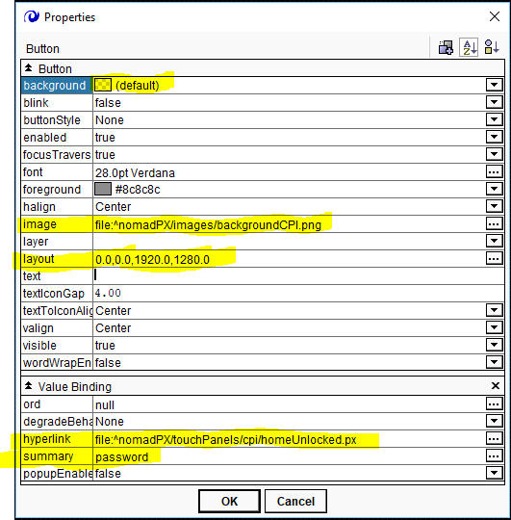

In the properties, the “summary” property is set to “password”. When the screen is pressed, it will ask for a password.

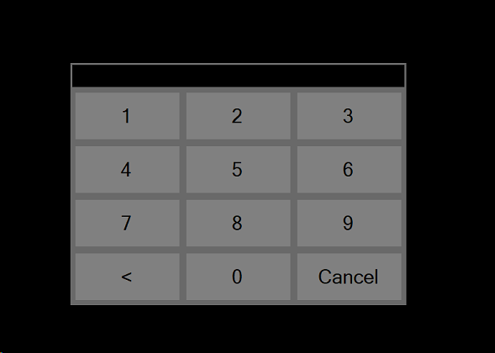

That password is loaded in the Kiosk App:

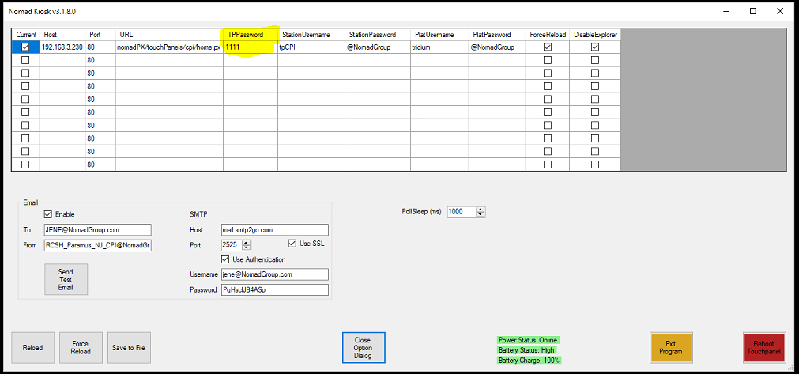

The **homeUnlocked.px** screen…all about the “Lock Screen” button.

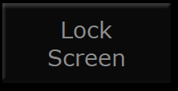

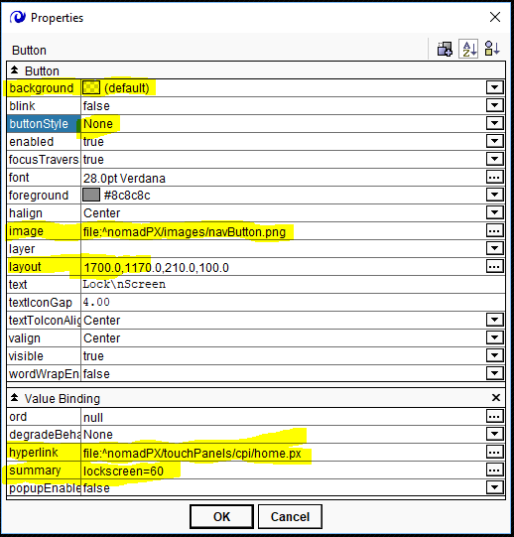

The “Lock Screen” button on the “climate.px” and the illumination.px page are the same.

The above set up is true for the bar, as well. The “temporary/px” page in the bar has the same “Lock Screen” button set up.

**Special Cases – The Private Dining Rooms set up.**

**The “home.px” page:**

Like the CPI and BAR home page, the home.px page in the PDR is a button. Here are the properties:

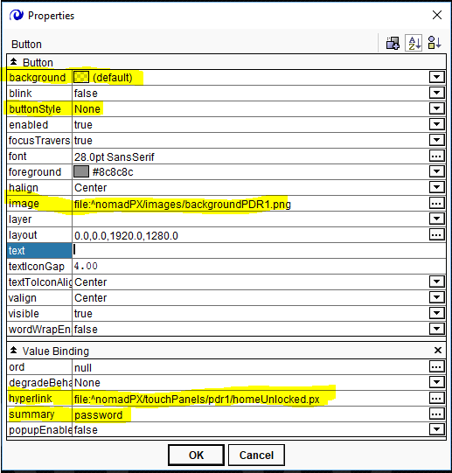

A different “Lock Screen” button:

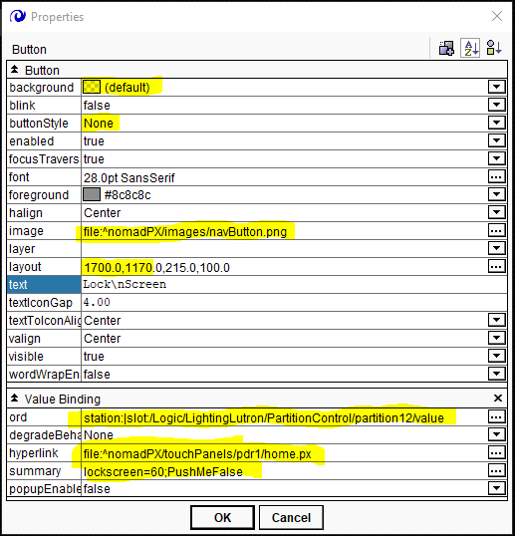

In the “Value Binding” property, the ORD field looks at the LightingLutron/PartitionControl/partition12/value

In the “Summary” field are two commands, “lockscreen=60” and “PushMeFalse” . These are part of the kiosk app. If after 60 seconds, there is no activity on the screen, then the screen bounces back to the home.px screen. If the ORD field goes false, then the command “PushMeFalse” happens and the screen is locked.

The 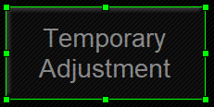 button is set up normally. It points to the “temporary.px” page.

The PDR1 “Rent as a Single Room” button:

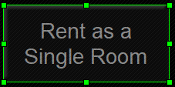

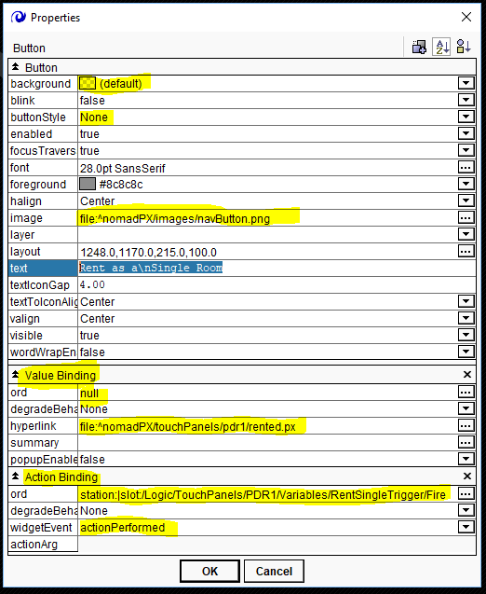

The Value Binding hyperlink field points at the “rented.px” button.

The Action Binding ORD field points at the “Logic/TouchPanels/PDR1/Variables/RentSingleTriggered/Fire” widget.

In the widgetEvent field, make sure you have selected “actionPerformed,” or it will not perform the action you want.

When you push the “Rent as a Single Room” button, the PDR partition stays closed, and the lighting and volume work independently of the other rooms.

**The “Rent as a Combined Room” button:**

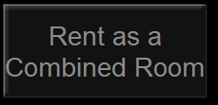

**The “Rent as a Combined Room” properties**

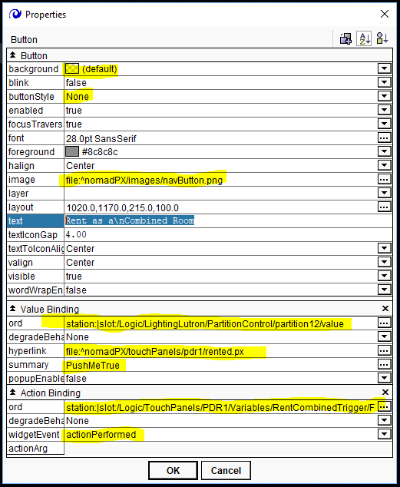

The Value Binding ORD points at : “station:|slot:/Logic/LightingLutron/PartitionControl/partition12/value”

The Hyperlink field points at : “file:^nomadPX/touchPanels/pdr1/rented.px”

Set Summary to “PushMeTrue.” If Either PDR pushes the “Combine” button, that ord will go “True” and take both TP’s to the “rented.px” page. Both TP’s lighting and AV will be in synch with each other.

Add an Action Binding from the Binding Dropdown selector: 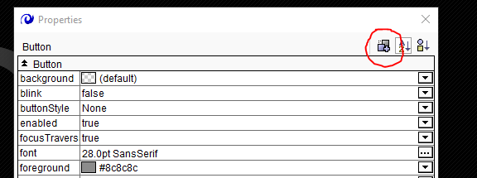

When you select it, this pops over the properties page:

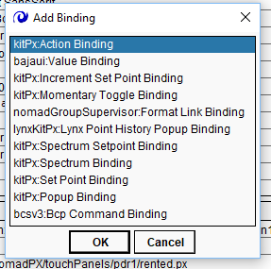

In the ORD field, select the little rectangular box with the three dots in it:



This will pop over the properties table:

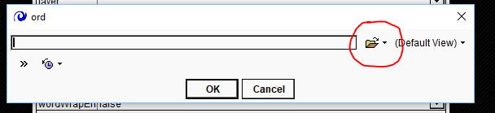

Click on the down arrow.

This menu will open up:

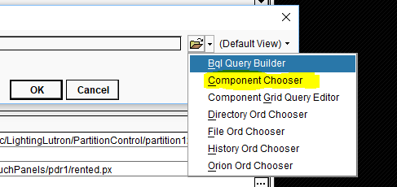

Select “Component Chooser”.

This will open up:

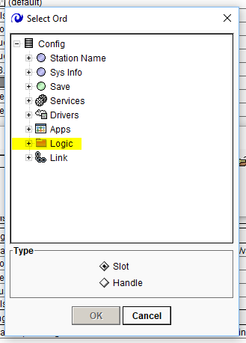

Select the + sign next to the “Logic” folder.

Select the “TouchPanels” folder:

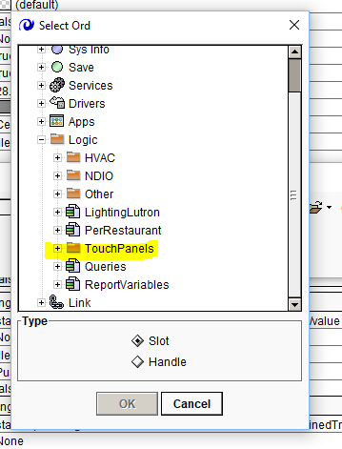

For this example, we are selecting the PDR1 folder:

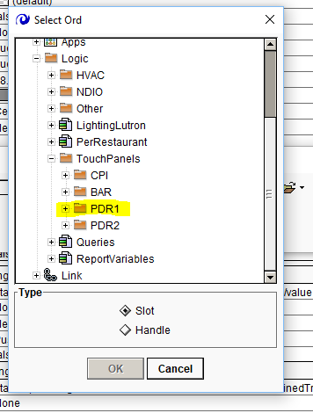

Select the “RentCombinedTrigger” widget and click on “Fire”

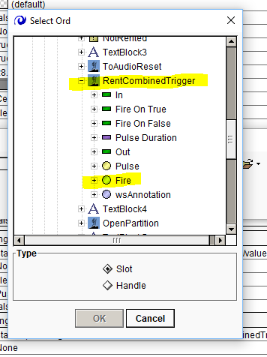

This is what will appear in the ORD field: “station:|slot:/Logic/TouchPanels/PDR1/Variables/RentCombinedTrigger/Fire”

Make sure the “widgetEvent” field is set to “actionPerformed.”

This will take you to the rented screen, open the partition and cause the lights and sound sliders to work as a unit instead of as separate PDRs.

**The ‘rented.px” page:**

The buttons on the “rented.px” page are “Lock Screen” and “Release Room”.

In the case of the “Lock Screen” button:

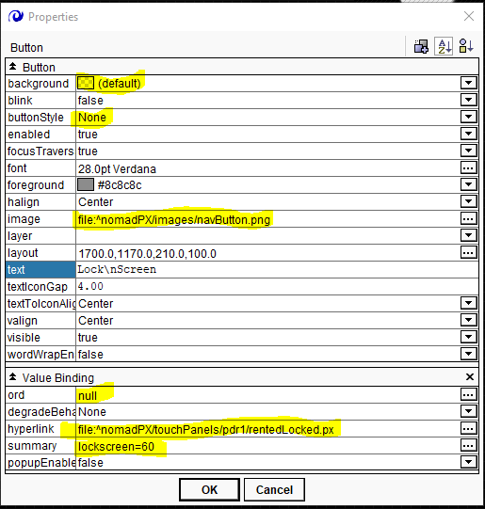

Make sure the ORD is null and that the hyperlink field points to: “file:^nomadPX/touchPanels/pdr1/rentedLocked.px”, and the summary field is set to “lockscreen=60” This forces the rented screen to return to the “rentedLocked.px” page after 60 seconds.

**The “Release Room” button.**

**Properties:**

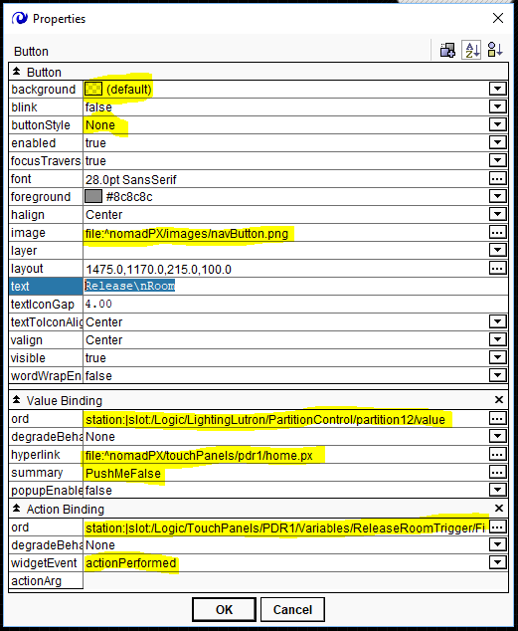

NOTE: In the “Value Binding”, “hyperlink” field, notice it is pointing back to the “home.px” page.

And the summary field is set to “PushMeFalse”. This way, if someone releases the room from the other touch panel, the ORD will read “false” and cause this TP to be released. The two TP’s are no longer in sync.

**The “rentedLocked.px” screen.**

Like the “home.px” screen, this is just a big button.

Here are the properties of this big button:

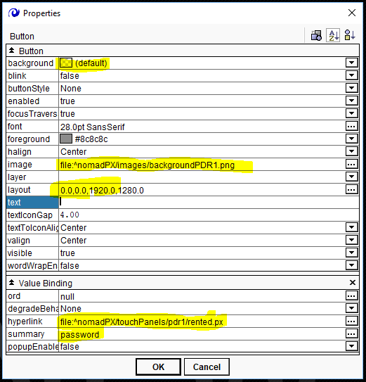

In this case, when you click the screen, you will be taken to the “rented.px” page.

**Make sure the summary field says “password”.**

When you click the “home.px” or the “rentedLocked.px” page, this will pop up on the Surface 3 screen:

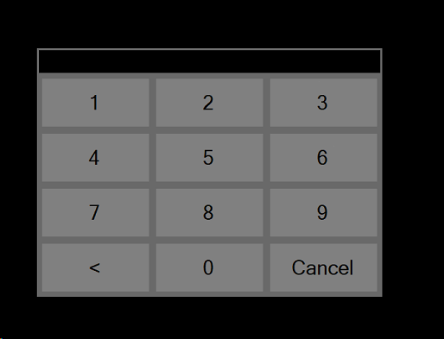

The actual password is a function of the Kiosk App.

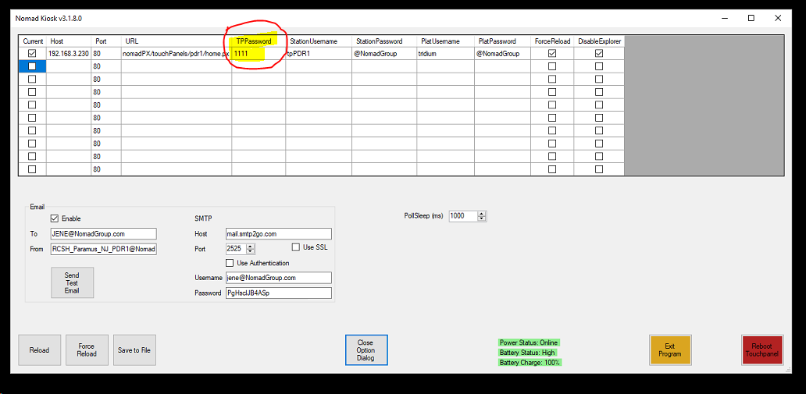

In the Kiosk, make sure the password is entered in the TPPassword field. In the case of RCSH Paramus, the password for the end user is 1111. There is another password that Nomads use, it is: 1132. It is not necessary to put that in the Kiosk app, as it is written in as a backdoor password.

**The “temporary.px” page:**

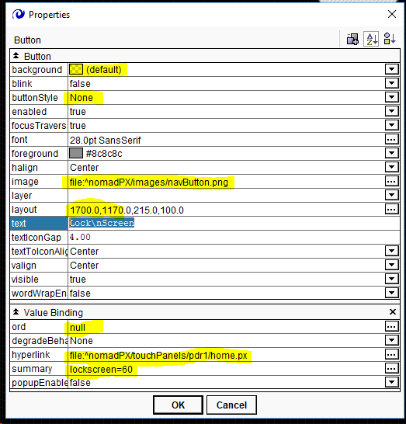

This one is set up like any normal “Lock Screen” button on any “temporary.px” page